50 Great Sparkling Wines of the World 2021
Sticker Order Form

Please email this form to media@winepleasures.com

PRICES

€65 + IVA per 1,000 with a minimum order of 2,000 stickers.

INVOICE details:
Company Name:
Contact name:
Street Address:
City/Town:
State/Province:
ZIP/Postcode:
Telephone:
Email:
VAT Number (MUST BE PROVIDED):

DELIVERY ADDRESS IF DIFFERENT TO BILLING ADDRESS
Company Name:
Contact name:
Surname:
Street Address:
City/Town:
State/Province:
ZIP/Postcode:
Country:
Telephone:
Please note: Minimum order quantity is 2000 pcs.
NAME OF WINE | MEDAL ACHIEVED | QUANTITY OF STICKERS

PAYMENT METHOD
Bank transfer– Bank details will be included on the invoice we send. Please note - stickers are only dispatched after the payment has been received)
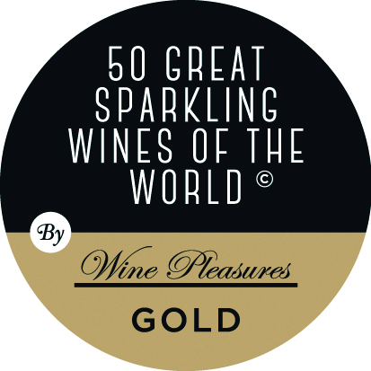 | 